Project Design Phase
Problem – Solution Fit Template

Date | 28 February 2026
Team ID | LTVIP2026TMIDS87250
Project Name | Smart Sorting: Transfer Learning for Identifying Rotten Fruits and Vegetables
Maximum Marks | 2 Marks

Problem – Solution Fit Template:
The Problem–Solution Fit means we’ve identified a real, recurring problem in the food industry—manual and error-prone sorting of fruits and vegetables—and we’ve built a technology-driven solution using transfer learning that actually addresses and improves this issue.
Purpose:
- Traditional sorting methods are manual, inconsistent, and labor-intensive. Our solution uses AI-based image classification to automate the identification of rotten vs. fresh produce, offering a cost-effective, accurate, and fast approach that aligns with the operational needs of retailers, farmers, food warehouses, and supermarkets.Succeed faster and increase your solution adoption by tapping into existing mediums and channels of behavior.
- Market messaging focuses on reducing food waste, lowering manual labor costs, and improving food quality control. Key triggers include profit loss due to spoilage, regulatory standards, and customer dissatisfaction due to poor quality produce.
- Our research into sorting operations in farmers' markets, food packaging centers, and supermarkets shows a demand for automation and quality control. The smart sorting system enhances existing workflows with minimal disruption, leading to better operational efficiency and food quality.

Template:
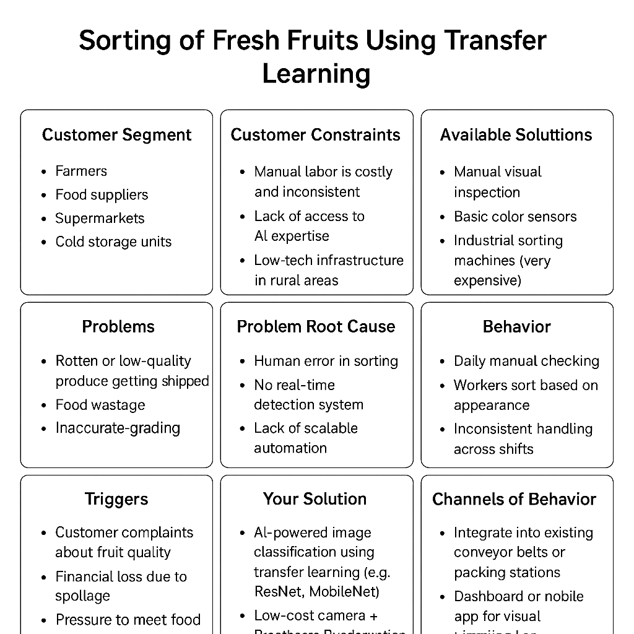

References:
- https://ashleyycz.medium.com/how-i-made-a-i-to-detect-rotten-produce-using-a-cnn-f2f16a316914
- https://www.researchgate.net/publication/365198552_SORTING_OF_FRESH_FRUITS_USING_TRANSFER_LEARNING

